**Diversity Mark Process Progress Checklist**

(Tick list to assist with monitoring progress of the process.) Page 1 of 7

|  |
| --- |
| **Phase 1: Preparing the Convenor** Plan a meeting with the convenor to introduce yourself as DMO and explain how you will be carrying out the review.Agree on the frequency of contact between yourself / the convenor, the mode of contact and the timeframe to do the review. Ask the convenor how to navigate the module. Request additional material. Request additional engagement (where appropriate) with sessions such as guest speakers or group discussions (if scheduled). Start the Review. Inform the convenor that communication may be very limited whilst undertaking the Review. Create a communication trail between yourself and the convenor. Always cc: your Development Officer (DO). |

|  |
| --- |
| **Phase 2: The Review Process** Start the Review, using the template as provided in the Handbook. After completing the Review, send the draft file to the convenor for feedback.In discussion with the convenor, set a date by when you would like to receive feedback from the convenor on your draft report.Ensure that all communication is done via email. Schedule a date and time with convenor to discuss the draft report.Make sure to record the meeting and ask permission from the convenor to do the recording.The recording is meant for evaluation purposes and to ensure that your DO is aware of what has been discussed. Before finishing the Review meeting, discuss and agree the next steps with the convenor. |

**Diversity Mark Process Progress Checklist**

Page 2 of 7

|  |
| --- |
| **Phase 3: Prepare the Presentation** Discuss with your DO the outcome of the one-to-one meeting with the convenor and agree on next steps. Adjust the draft report based on the feedback received from the convenor and what was discussed at the one-to-one meeting. Prepare the final official report and presentation for review by the convenor and other relevant staff.This report should also be presented at one of the regular DMO team meetings with the Student Success team.Kerry Shelton should receive a copy of the report as well. |

|  |
| --- |
| **Phase 4: The Plan of Action (POA)** Based on the results of the review and the ‘next steps’, prepare an official POS for the module.The POS serves as the ‘road to diversifying the module’. Part of the POA should include undertaking a focus group and establishing collaboration with the Library. Present the POS to the convenor and set a timeline for implementation of the POA. The POA should be supported by a couple of recommendations.These recommendations usually reflect additional information/ideas for the convenor to incorporate within the POA.The POA should be discussed in close collaboration with the DO, the convenor and with eventual input from the SDMO (Senior Diversity Mark Officer). |

** Diversity Mark Process Progress Checklist** Page 3 of 7

|  |
| --- |
| **Phase 5: Plan Your Focus Group Event** Identify topics in the module that can be further discussed in a focus group. Request from the convenor access to the students’ email addresses. Decide whether it would be a combined focus group activity (black and white students) or an only black students event. Email the selected students to request availability for the focus group event. Create a consent form for students to sign when taking part in the focus group. Record the focus group (make sure to request permission from those taking part). Process the results of the focus group in a report. Include the outcome of the focus group and the students’ advice on implementing new ideas/adjustments to the module in the POA. |

|  |
| --- |
| **Phase 6: The Road to the Award** Follow up on the convenors commitment to implement the full POA or parts of it. Provide guidance. Ask the convenor to fill out the Diversity Mark Award forms. Provide guidance. Compile all the evidence to support you decision of nominating the convenor. Evidence should be visible and tangible. Provide Kerry Shelton and your DO with a comprehensive file containing all the required documents to support your nomination. Prepare to defend your convenor’s nomination during the panel’s meeting. Inform your convenor clearly about the steps towards the award and the timeframe in the run up to being awarded. Keep in touch with the students who contributed to the focus group. Once the award ceremony is scheduled these students should receive recognition as well. |

** Diversity Mark Process**

Attachment 1 Page 4 of 7

# **The Pillars to build on Equality, Diversity and Inclusion in a module**

|  |
| --- |
| **Visibility of the student’s voice – students becoming co-producers:** the need to provide insights from both the convenor’s and students’ perspective. This can be achieved through including confession-videos of students, or a section in the module where students can upload reading material and other resources of their choice. |
| **A place of belonging:** all students should feel a sense of belonging, respected and represented in resources provided throughout the module and during discussions in lectures. |
| **Inspiring role models:** students should be able to identify role models through the resources; person who can be of inspiration to them; persons who they can look up to and learn how to prepare their career path or visualise their aspirations. |
| **Gender conscious:** students should not feel offended in their gender preference by the choice of resources; resources should not provoke students to feel stigmatised, generalised or put in a box because of their gender. |
| **Worldwide knowledge – visibility of Global Authors:** resources should represent not just the Westernised, Eurocentric view on knowledge. Convenors should aim to expose students to the experience of other knowledge systems and non-European authors relevant to the module subject. |
| **Avoid Triple Burden Effect** (They live it, they deal with it, and they have to teach others how to deal with them): students relating to a marginalized community, such as BME, Muslim, LGBTQ, should not be ‘burdened’ by the convenor with the responsibility to help other students understand their lived experiences. Within the module, and in case the module lends itself to such opportunities, the convenor could provide a platform for these students whereby they can share their experiences without being judged. Such incidences can be established through virtual platforms or audio-visual productions. During classroom discussions the convenor should be prepared to be a facilitator of the discussions and not just a listener. |
| **Disclaimers to prevent and prepare:** in the case of sensitive and offensive information in a module, the convenor should make sure to include a disclaimer to prepare students for possible emotional responses and to prevent the occurrence of offensive behaviour from students. |

** Diversity Mark Process**

Attachment 2 Page 5 of 7

**Template to be used to produce the review report.**

Note: Report should be produced in an excel spreadsheet consisting of the following tables:

Table template showing the different categories along the horizontal axis that should be considered and included in the 
POA.  

Table 1 (above): an overview of all the data collected from the module through reading lists and additional teaching material reviewed per lecture week.

** Diversity Mark Process**

Page 6 of 7

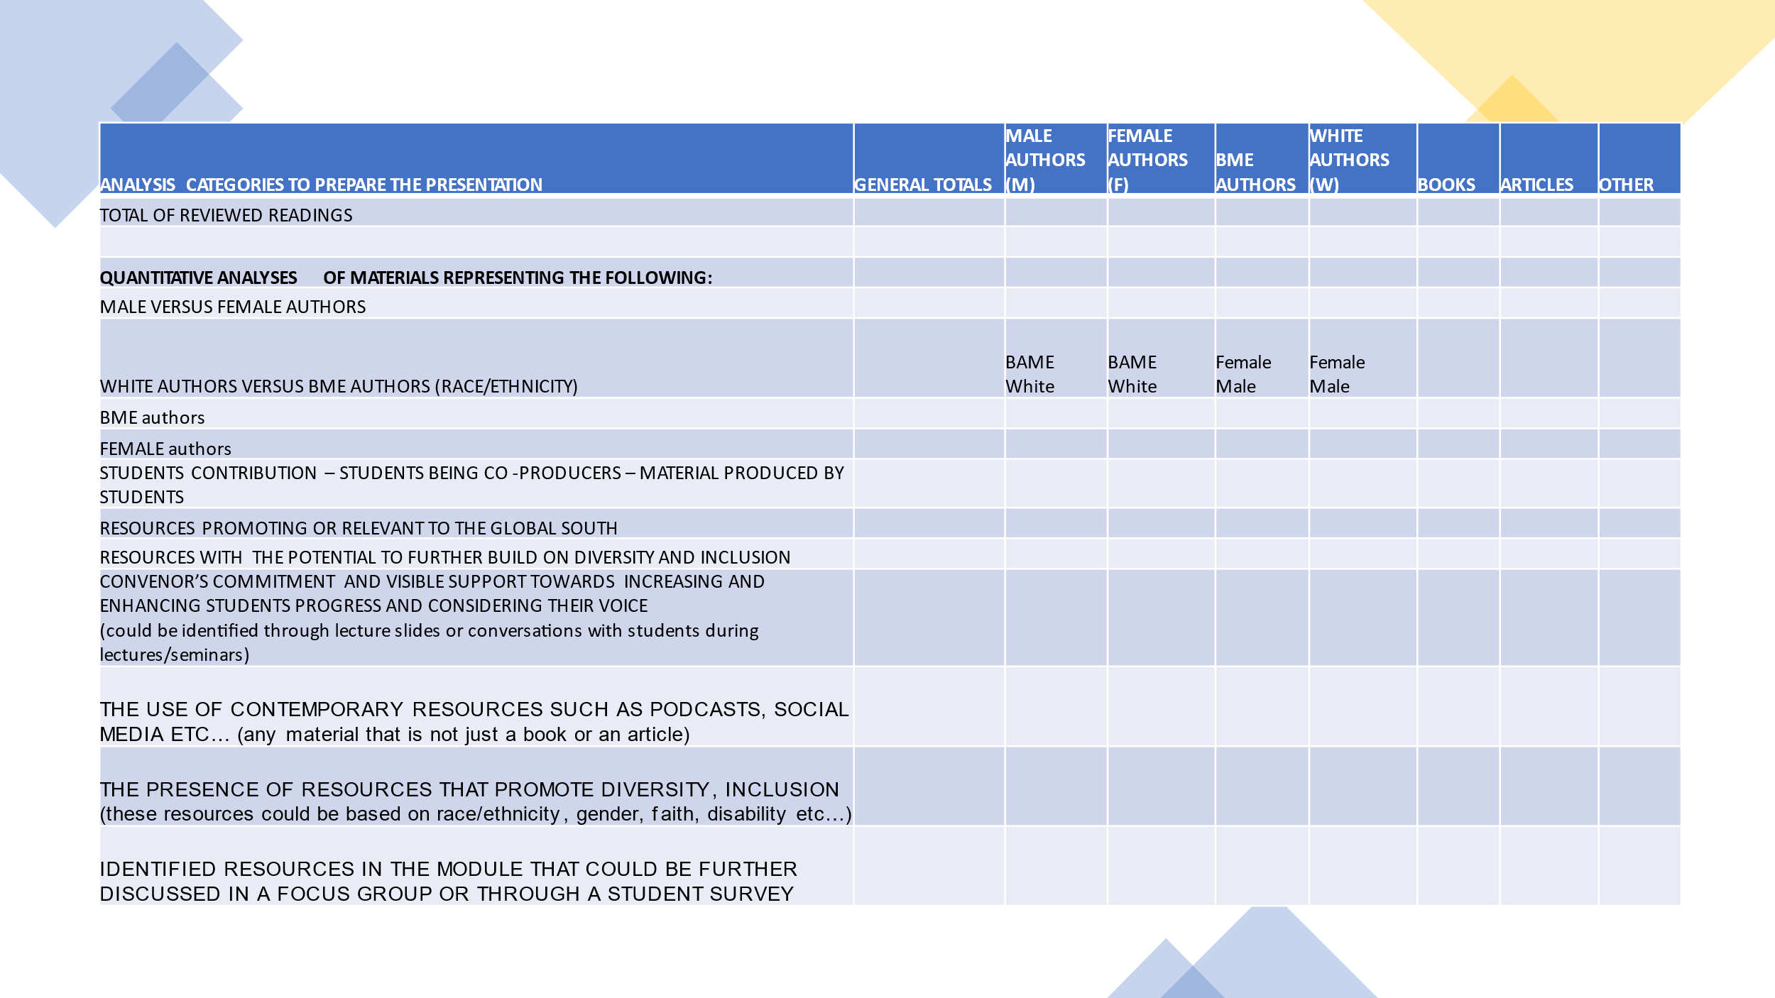Table 2 (above): Analysis report reflecting quantitative results. These categories can serve as topics/themes in the presentation of the results of the module.

** Diversity Mark Process**

Page 7 of 7

Table 3 (below): descriptive account of the results. This would be valuable for further discussion with the convenor and to draw recommendations and conclusions and a thorough POA.

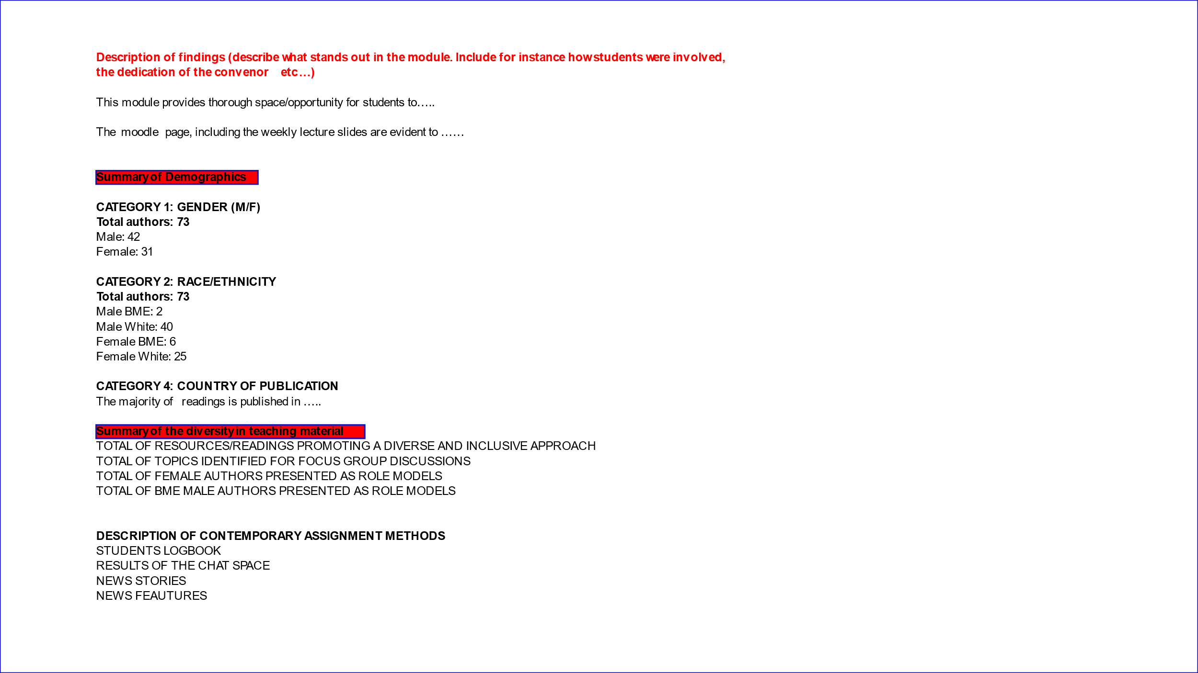

This document has been checked for accessibility.